#### [Easy Rev](http://timisoaractf.ro/challenge?id=15) (75pts)

Running ltrace on the binary we can see that it does some transformation on the input string(in my case ‘"aaaaaaaaaaaaaaaaaa") and then compares it with some hardcoded string

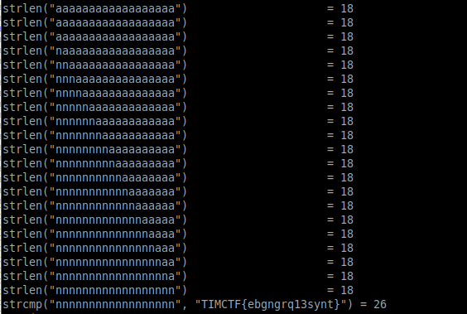

Trying the hardcoded string as the input reveals the flag:

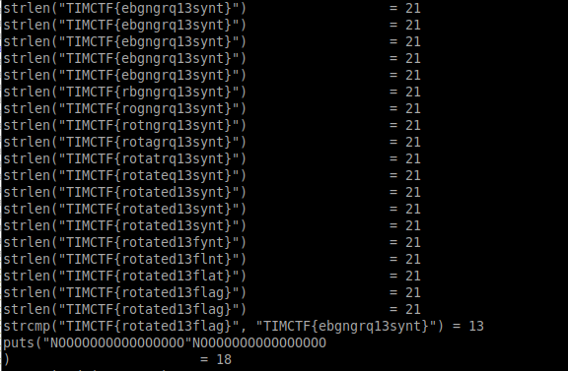

Bonus: We discovered in the process that this transformation was in fact ROT13